**Study Material**

**(Introduction)**

**___________________________________________________________________________**

**Table of Contents**

|  |  |  |
| --- | --- | --- |
| **Module No.** | **Module Name** | **Content** |
| **Module 1** | **Introduction to Artificial Intelligence** | Problem Solving in AI |
| Production systems |
| State space representation |

**Problem Solving and State Space Representation**

Problem-solving in Artificial Intelligence often involves agents navigating a **state space** to achieve a desired **goal**. This approach is fundamental to how intelligent systems find sequences of actions to reach a solution.

A **search problem** is a formal definition used in Artificial Intelligence to describe how an agent can find a sequence of actions, or a **path**, to achieve a desired **goal state** from an **initial state** within an environment. This process is central to how intelligent systems discover solutions.

A search problem is formally defined by the following components:

* **States**: A **set of possible states** that the environment can be in. Each state represents a complete snapshot of the world at a given moment. For example, in a vacuum cleaner world, a state might specify the agent's location and whether each square is dirty or clean. For the 8-puzzle, a state describes the location of each tile.
* **Initial State**: The **starting state** where the agent begins. In a route-finding problem, this could be the city of Arad.
* **Goal States**: A **set of one or more states** that represent the desired outcome. This can be a specific state (like Bucharest in a route-finding problem), a small set of alternatives, or a property that applies to many states (e.g., all squares being clean in a vacuum world). An IS-GOAL method is used to determine if a state satisfies the goal.
* **Actions**: The **actions available** to the agent from any given state s, which can be executed to transition to a new state. These actions are considered "applicable" in that state. In the two-cell vacuum world, actions include Suck, move Left, and move Right. For route-finding, actions are traveling between adjacent cities.
* **Transition Model**: This **describes what each action does**, mapping a current state s and an action a to a resulting state s' (denoted as RESULT(s, a) = s'). For example, applying ToZerind from Arad results in the Zerind state.
* **Action Cost Function**: A **numeric cost** associated with applying an action a in state s to reach state s'. This is denoted as ACTION-COST(s,a,s') or c(s,a,s'). For route-finding, this cost might be the distance in miles or time taken, and costs are assumed to be additive.

A **solution** to a search problem is a **path** (a sequence of actions) from the initial state to a goal state. An **optimal solution** is the path with the lowest total cost among all possible solutions.

A **state space representation** (or state space model) is essentially the formal structure that defines a search problem. It describes the environment in which an intelligent agent operates and aims to solve a problem.

* The **state space** can be visualized as a **graph**, where states are vertices (nodes) and actions are directed edges between them. For example, the map of Romania, with cities as states and roads as actions, is a graph representing a state space.
* It's important to distinguish between the **state space** (the set of all possible world configurations) and the **search tree**. While the state space might contain cycles (e.g., Arad to Sibiu and back to Arad), a search tree describes paths between these states, and each node in the tree has a unique path back to its root. Search algorithms often superimpose a search tree over the state-space graph.
* A key aspect of problem formulation is **abstraction**, which involves removing irrelevant details from the real-world representation to simplify the problem into a manageable state space. A good abstraction retains only details relevant to the agent's actions and goals, ensuring that any abstract solution can be elaborated into a real-world solution. Without useful abstractions, intelligent agents would be overwhelmed by the complexity of the real world.

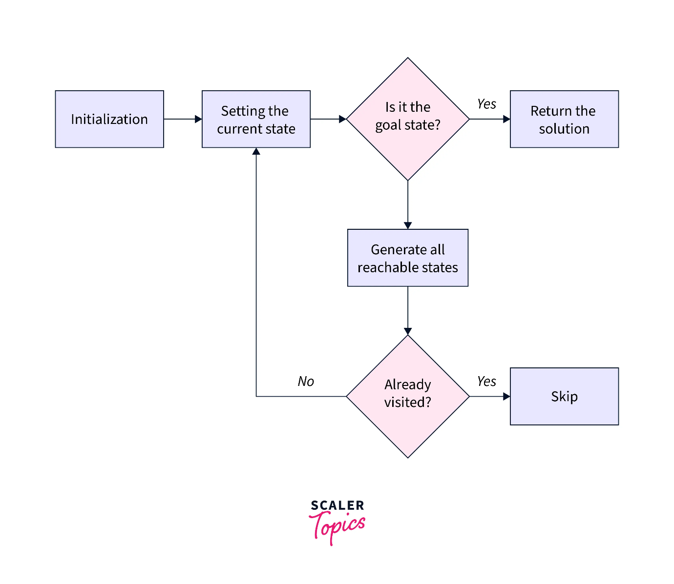

**Problem-solving through production systems** is closely related to how agents make decisions within a state space. While the term "production system" itself is not a primary paradigm explicitly defined in the provided text, the underlying concepts are very present:

* **Condition-action rules** (also known as situation-action rules or if-then rules) are a fundamental building block. These rules directly map a current percept or state description to an action. Simple reflex agents operate entirely on these rules, selecting actions based solely on the current percept. This embodies a basic form of a production system, where a set of rules (rules) are applied by an interpreter (RULE-MATCH) based on the current state (state← INTERPRET-INPUT(percept)) to select an action.
* Historically, early AI systems like the **General Problem Solver (GPS)** by Allen Newell and Herbert Simon aimed to imitate human problem-solving protocols through symbolic manipulation. Their work led to the **physical symbol system hypothesis**, proposing that intelligence operates by manipulating data structures composed of symbols. This aligns with the idea of a production system, where rules manipulate symbolic representations of the world to derive actions.
* The development of **expert systems** like DENDRAL and MYCIN in the 1970s and 80s further relied on "large numbers of special-purpose rules" to encode domain-specific knowledge. These systems used a "knowledge-intensive" approach, acquiring rules from human experts, which again reflects a rule-based or production system approach to problem-solving within a defined domain.

**Applications and Use Cases of State Space Representation:** The concept of state space representation is fundamental to solving a wide array of problems in AI, ranging from simplified benchmark puzzles to complex real-world challenges:

* **Standardized Problems**: These are often used to illustrate and test problem-solving methods.
  + **Grid World Problems**: Like the vacuum world or **Sokoban puzzles**, where agents navigate cells and manipulate objects.
  + **Sliding-Tile Puzzles**: Such as the **8-puzzle** or **15-puzzle**, where the goal is to arrange numbered tiles by sliding them into a blank space.
  + **Knuth's "4" Problem**: Illustrates how problems can have **infinite state spaces** by applying mathematical operations (square root, floor, factorial) to numbers to reach a desired integer.
* **Real-World Problems**:
  + **Route-Finding Problems**: Used extensively in **Web mapping services** (e.g., Google Maps) and **in-car navigation systems** to find optimal routes. Also applied in complex logistical challenges like **military operations planning** and **airline travel planning systems**.
  + **Touring Problems**: Such as the **Traveling Salesperson Problem (TSP)**, which seeks the lowest-cost tour visiting a set of locations, with applications in optimizing school bus routes.
  + **VLSI Layout**: Positioning millions of electronic components on a chip to minimize area and optimize performance, involving complex search problems for cell layout and channel routing.
  + **Robot Navigation**: A generalization of route-finding where robots move in continuous, multi-dimensional spaces, requiring advanced techniques to manage the complexity.
  + **Automatic Assembly Sequencing**: Determining the optimal order to assemble parts of complex objects, a standard industrial practice since the 1970s, also related to **protein design**.

In essence, the state space representation provides the structured map of possible scenarios and transitions for an AI agent. Problem-solving through production systems (or rule-based reasoning, or search algorithms) then provides the means for the agent to navigate this map, making decisions about which actions to take to move from the current state towards a goal state, much like a meticulous explorer (the agent) uses a detailed map (the state space representation) and a comprehensive guide of local customs and survival techniques (the production system/rules) to journey from a starting point to a desired destination.

**State Space Representation**

A **search problem** is formally defined using a **state space representation**, which provides a structured way to describe the environment and the agent's interaction within it. Key components of this representation include:

* **States**: A **set of possible states** the environment can be in. Each state represents a complete snapshot of the world at a given moment. For example, in a vacuum cleaner world, a state might specify the agent's location and whether each square is dirty or clean. In a 3x3 8-puzzle, a state describes the arrangement of the eight numbered tiles and the blank space.
* **Initial State**: The **starting state** of the agent. For instance, starting in the city of Arad in a route-finding problem.
* **Goal States**: A **set of one or more states** that define the desired outcome. Sometimes it's a specific single state (e.g., Bucharest in a route-finding problem), a small set of alternatives, or a property that applies to many states (e.g., all squares being clean in a vacuum world, regardless of the agent's location).
* **Actions**: The **actions available** to the agent from a given state, which can be executed to transition to a new state. These actions are considered "applicable" in that state. For example, in the vacuum world, actions include "Suck," "move Left," or "move Right".
* **Transition Model**: This **describes what each action does**, mapping a current state and an action to a resulting state. For example, applying "ToZerind" from "Arad" results in the "Zerind" state.
* **Action Cost Function**: A **numeric cost** associated with applying an action in a state to reach a new state. For route-finding, this might be distance in miles or time taken. **Optimal solutions** are those with the lowest total path cost, assuming additive costs.

The **state space** can be visualized as a **graph**, where states are vertices and actions are directed edges between them. When agents search this graph, they construct a **search tree**, where nodes represent states and edges represent actions. A crucial distinction is that the search tree can have multiple paths (and thus multiple nodes) leading to the same state in the state space.

**Abstraction** is a key aspect of problem formulation, involving the removal of irrelevant details from a representation to simplify the problem. A good abstraction helps agents find solutions without being overwhelmed by the complexity of the real world.

**Problem-Solving through Production Systems**

While the sources do not explicitly use the term "production systems" as a primary paradigm, they describe similar concepts, particularly in the context of how agents make decisions based on perceived conditions and stored knowledge.

The closest concept discussed in the provided text is the **"condition–action rule"**. These rules, also known as situation–action rules or if–then rules, are the basis of **simple reflex agents**. These agents select actions directly based on the current percept, effectively ignoring past percepts. For instance, a simple vacuum agent's behavior "if current square is dirty, then suck; otherwise, move to the other square" is an example of a condition-action rule. This can be implemented as a general-purpose interpreter for such rules, where an INTERPRET-INPUT function abstracts the current state, and RULE-MATCH finds a rule that matches this state description to return an action.

For more complex scenarios, especially in partially observable environments, simple reflex agents are limited because they cannot maintain an internal understanding of the world. This leads to **model-based reflex agents**, which maintain an "internal state" representing unobserved aspects of the current world. This internal state is updated using a "transition model" (how the world changes over time, including effects of agent actions) and a "sensor model" (how the world state is reflected in percepts). Once the internal state is updated, these agents still use condition-action rules to select an action.

Furthermore, the "early enthusiasm" period of AI, particularly with systems like **Logic Theorist (LT)** and the **General Problem Solver (GPS)** by Newell and Simon, embodies problem-solving through **symbolic manipulation and reasoning**. GPS was designed to imitate human problem-solving protocols, leading to the **physical symbol system hypothesis**, which posits that any intelligent system (human or machine) operates by manipulating data structures composed of symbols. This aligns with the principles of rule-based or production systems, where knowledge is explicitly represented and manipulated to derive actions.

The later development of **expert systems** (e.g., DENDRAL, MYCIN) also relied on "large numbers of special-purpose rules" to encode domain-specific knowledge, moving away from "weak methods" of general search. This "knowledge-intensive" approach involved acquiring rules from human experts, demonstrating another form of problem-solving driven by a collection of production-like rules.

**Applications and Use Cases of State Space Representation**

The concept of state space representation is widely applied across various AI domains:

**Standardized Problems (Benchmarks)**:

* **Grid World Problems**: Agents move between cells, interacting with objects or obstacles. Examples include the vacuum world (agent cleans dirty squares) and **Sokoban puzzles** (agent pushes boxes to target locations).
* **Sliding-Tile Puzzles**: Such as the **8-puzzle** or **15-puzzle**, where tiles are slid into a blank space to reach a goal configuration.
* **Knuth's "4" Problem**: An example illustrating problems with **infinite state spaces** where actions (square root, floor, factorial) transform numbers to reach a desired integer.

**Real-World Problems**:

* **Route-Finding Problems**: Used in **Web mapping services** (like Google Maps) and **in-car navigation systems** to find optimal routes between locations, considering factors like traffic. Also applied in complex logistical challenges such as **military operations planning** and **airline travel planning**.
* **Touring Problems**: Involve visiting a set of locations, like the **Traveling Salesperson Problem (TSP)**, which aims to find the lowest-cost tour visiting every city. This has applications in optimizing **school bus routes**.
* **VLSI Layout**: Positioning millions of electronic components and connections on a chip to minimize area, circuit delays, and maximize manufacturing yield.
* **Robot Navigation**: A generalization of route-finding, where a robot moves in a continuous multi-dimensional space (e.g., controlling arms and legs).
* **Automatic Assembly Sequencing**: Determining the optimal order to assemble parts of complex objects, a standard practice in industry since the 1970s. This also extends to **protein design**, finding amino acid sequences for specific protein properties.

In essence, **state space representation** provides the map and rules for an AI agent's journey, while the agent's **program (akin to a production system or logical rules)** acts as the set of instructions and decision-making mechanisms for navigating that map effectively. It's like a chef (the agent) who has a detailed recipe book (the production system/rules) to transform ingredients (the current state) into a delicious meal (the goal state) by following steps (actions) and knowing how each step changes the dish (transition model), all while being mindful of the cost of each ingredient and cooking step (action cost function).

**Search Problems and their Relation with State Space**

A **search problem** provides a formal structure for an intelligent agent to discover a sequence of actions, or a **path**, that leads from an **initial state** to a desired **goal state** within an environment. It's a fundamental concept in Artificial Intelligence (AI) for finding solutions to problems.

A **state space model** is the formal representation of the environment in which a search problem is defined. It essentially maps out all possible configurations of the world and the transitions between them.

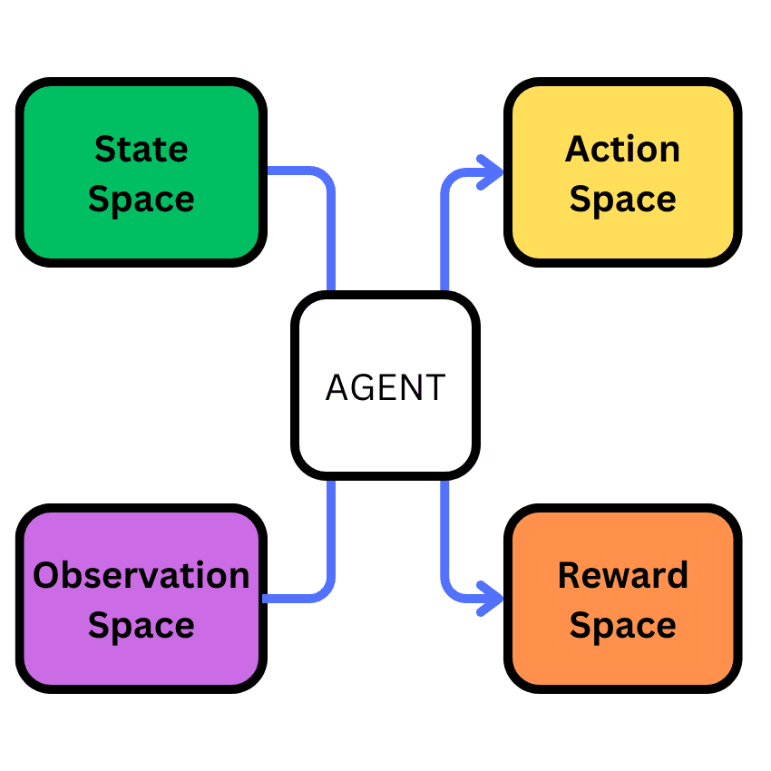

Here's how they relate to intelligent agents:

* **Components of a Search Problem / State Space Model**: A search problem, and by extension its state space model, is formally defined by these key elements:
  + **States**: A **set of possible configurations** the environment can be in, representing a complete snapshot of the world. For example, in the 8-puzzle, a state describes the arrangement of all tiles.
  + **Initial State**: The **specific starting point** for the agent. In a route-finding problem like navigating Romania, this would be the city of Arad.
  + **Goal States**: One or more **desired configurations** that the agent aims to reach. This can be a specific state (like Bucharest), a set of states, or a property that defines success (e.g., all squares being clean in a vacuum world). An IS-GOAL method determines if a state meets the goal criteria.
  + **Actions**: The **set of available moves** an agent can perform from any given state s. These actions are "applicable" in s. For instance, from Arad, actions could be ToSibiu, ToTimisoara, or ToZerind.
  + **Transition Model**: This **describes the outcome** of performing an action a in state s, leading to a new state s' (denoted RESULT(s, a) = s').
  + **Action Cost Function**: A **numeric cost** associated with each action, typically ACTION-COST(s, a, s'). Costs are usually additive, meaning the total path cost is the sum of individual action costs. This cost should reflect the agent's performance measure.
* **Agents and their Interaction with State Space Models**:
  + **Problem-Solving Agents**: These agents explicitly **devise an abstract model** (a state space representation) of the relevant part of the world to plan actions. Before acting in the real world, they **simulate sequences of actions** within this model, searching for a solution. The solution is a "path," a sequence of actions from the initial state to a goal state.
  + **Intelligent Agent Paradigm**: The core idea in AI is the **intelligent agent**, which perceives its environment through sensors and acts upon it through actuators. The **state space** *is* this environment, or at least the relevant part of it that the agent needs to consider.
  + **Abstraction**: A crucial step in formulating a problem is **abstraction**, which involves removing irrelevant details from the real world to simplify it into a manageable state space. A good abstraction ensures that solutions found in the abstract state space can be translated back into real-world actions. Without abstraction, intelligent agents would be overwhelmed by the complexity of the real world.
  + **Internal State and Models**:
    - **Simple Reflex Agents** are the most basic, acting solely on the **current percept**. They *do not* maintain an internal model of the state space beyond what is immediately perceived, making them limited in partially observable environments where important information might be hidden.
    - **Model-Based Reflex Agents** overcome partial observability by explicitly maintaining an **internal state** that tracks unobserved aspects of the current world state. This internal state is updated using a **transition model** (how the world changes, including the effects of the agent's actions) and a **sensor model** (how the world state is reflected in percepts). This internal state provides the agent's "best guess" of "what the world is like now".
    - **Goal-Based Agents** leverage the understanding of the current state (often from a model) and combine it with **goal information** to decide actions that will eventually achieve their objectives. These agents use search and planning algorithms to navigate their internal state space representation to find paths to goals.
    - **Utility-Based Agents** go beyond simple goals by incorporating a **utility function**, which is an internalization of the performance measure. This allows them to compare the desirability of different states and action sequences within the state space, especially when goals conflict or outcomes are uncertain. They aim to maximize "expected utility" within the state space.
  + **Learning Agents**: These agents are designed to **improve their components** over time, including their internal models of the state space. They use feedback from a "critic" to understand how well they are doing and adjust their understanding of "what my actions do" and "how the world evolves". This means their internal state space model can evolve and become more accurate through experience.
* **State Space as a Graph**: The state space can be conceptualized as a **graph**, where each state is a **vertex (node)** and each action is a **directed edge** connecting states. Search algorithms, such as **best-first search**, explore this graph by expanding nodes and generating child nodes corresponding to successor states. It's crucial to distinguish between the abstract state space graph and the **search tree**, which is a path-dependent structure built *over* the state space during the search process, and can contain multiple nodes (paths) leading to the same state.

In essence, the state space model is the **map** of the problem, detailing every possible location (state) and every route (action) between them, along with their associated costs. The intelligent agent is the **traveler** who uses this map (or builds one through experience) and its internal decision-making system (reflexes, goals, utility functions, and learning capabilities) to navigate from its current position (initial state) to its desired destination (goal state), striving to find the most efficient or optimal path.

A **state space model** is the formal representation of an environment within which an intelligent agent solves a **search problem** [previously discussed]. It essentially maps out all possible configurations of the world and the transitions between them, allowing an agent to plan a sequence of actions to achieve a goal [previously discussed, 334].

Here's a comprehensive breakdown of state space models, including their graph representation, working principles, application areas, and real-world problem-solving capabilities:

**Representation as a Graph**

A search problem, which operates within a state space model, is formally defined by several key elements:

* **States**: These are a set of possible configurations the environment can be in, representing a complete snapshot of the world. For example, in the 8-puzzle, a state describes the arrangement of all tiles [previously discussed].
* **Initial State**: This is the specific starting point for the agent. For instance, if an agent is navigating Romania, its initial state might be the city of Arad.
* **Goal States**: These are one or more desired configurations the agent aims to reach. A method IS-GOAL determines if a state meets the criteria for success, such as all squares being clean in a vacuum world.
* **Actions**: These are the available moves an agent can perform from any given state s. ACTIONS(s) returns a finite set of applicable actions. For example, from Arad, actions could be ToSibiu, ToTimisoara, or ToZerind.
* **Transition Model**: This describes the outcome of performing an action a in state s, leading to a new state s' (denoted RESULT(s, a) = s').
* **Action Cost Function**: A numeric cost, ACTION-COST(s, a, s') or c(s, a, s'), is associated with each action, typically reflecting the agent's performance measure. Total path cost is usually the sum of individual action costs.

The **state space can be represented as a graph** where each state is a **vertex (node)** and each action is a **directed edge** connecting states. For example, the map of Romania, showing cities as states and roads as actions, is such a graph. It is important to distinguish this abstract state space graph from the **search tree**, which is a path-dependent structure built *over* the state space during the search process, and can contain multiple nodes (paths) leading to the same state. The search tree's root node corresponds to the initial state, and expanding a node involves generating new child nodes (successor nodes) for each resulting state via applicable actions.

**Working Principle: Problem-Solving by Searching**

Intelligent agents, particularly **problem-solving agents**, explicitly devise an abstract model (a state space representation) of the relevant part of the world to plan actions [previously discussed, 334]. Their interaction with state space models follows a four-phase process:

1. **Goal Formulation**: The agent defines its objective, which helps limit the actions to consider.
2. **Problem Formulation**: The agent describes the states and actions needed to reach the goal, creating an abstract model of the environment.
3. **Search**: Before acting in the real world, the agent **simulates sequences of actions** within this model, searching for a **solution** (a path from the initial state to a goal state). This process involves exploring the state-space graph by expanding nodes and maintaining a **frontier** of unexpanded nodes. Search algorithms aim to find an optimal solution, which has the lowest path cost.
4. **Execution**: Once a solution path (sequence of actions) is found, the agent executes these actions in the real world, one at a time. In fully observable, deterministic, and known environments, this can be an "open-loop" system where percepts are ignored during execution. However, in uncertain environments, a "closed-loop" approach monitoring percepts is safer.

Search algorithms can be:

* **Uninformed Search Strategies**: These algorithms operate without any domain-specific hints about the closeness of a state to the goal. Examples include **breadth-first search** (which is complete and optimal for equal-cost actions but memory-intensive) and **uniform-cost search** (which is complete and cost-optimal for varying action costs). They can face challenges with exponential complexity and getting stuck in infinite loops in cyclic or infinite state spaces if not handled carefully.
* **Informed (Heuristic) Search Strategies**: These use **domain-specific hints** in the form of a **heuristic function**, h(n), which estimates the cost from a node n to a goal state. Examples include:
  + **Greedy best-first search**, which expands nodes closest to the goal according to the heuristic h(n). It is fast but not guaranteed to find an optimal solution.
  + **A* search**, which is the most common informed search algorithm, uses an evaluation function f(n) = g(n) + h(n), where g(n) is the path cost from the initial state and h(n) is the estimated cost to the goal. **A\*** is complete and cost-optimal if its heuristic is **admissible** (never overestimates the true cost) and **consistent** (satisfies the triangle inequality). It prunes away unnecessary search tree nodes, making it efficient.

To manage the exponential time and space complexity often encountered in large state spaces, advanced techniques are employed:

* **Redundant Paths/Cycles**: Search algorithms keep track of previously reached states to avoid repeatedly exploring the same parts of the state space.
* **Memory-bounded search**: Algorithms like IDA* (Iterative-Deepening A*) and SMA* (Simplified MA*) are designed to work within memory constraints by revisiting nodes or discarding the "worst" nodes, trading time for space.
* **Bidirectional search**: This approach simultaneously searches forward from the initial state and backward from the goal state, aiming for the two searches to meet in the middle, potentially reducing the search space significantly.

**Application Areas**

State space models and search algorithms are fundamental to various AI applications:

* **Standardized Problems** (benchmarks for algorithms):
  + **Vacuum World**: A simple grid environment where the agent cleans dirty squares.
  + **Sokoban Puzzle**: Involves pushing boxes to designated storage locations in a grid.
  + **Sliding-Tile Puzzles** (e.g., 8-puzzle, 15-puzzle): Arranging numbered tiles in a grid by sliding them into a blank space.
  + **Knuth's "4" Problem**: Reaching any positive integer starting from 4 using square root, floor, and factorial operations, which can lead to infinite state spaces.
* **Real-World Problems** (solutions used by people):
  + **Route-Finding**: Used in navigation systems (e.g., car GPS, Google Maps) and airline travel planning, accounting for factors like traffic, costs, and connections.
  + **Touring Problems** (e.g., Traveling Salesperson Problem (TSP)): Visiting a set of locations with minimal cost, applicable to vehicle routing and logistics.
  + **VLSI Layout**: Positioning millions of components on a chip to minimize area, delays, and maximize yield.
  + **Robot Navigation**: Generalizing route-finding for robots in continuous, multi-dimensional spaces, dealing with sensor errors and partial observability.
  + **Automatic Assembly Sequencing**: Determining the optimal order to assemble parts of an object.
  + **Protein Design**: Finding amino acid sequences that fold into specific 3D protein structures to cure diseases.

**Real-World Problem-Solving Capabilities**

The effectiveness of state space models in real-world problem solving hinges on several factors:

* **Abstraction**: A crucial step in formulating a problem is **abstraction**, which involves removing irrelevant details from the real world to simplify it into a manageable state space [previously discussed, 347, 348]. A good abstraction ensures that solutions found in the abstract state space can be translated back into real-world actions effectively. Without abstraction, intelligent agents would be overwhelmed by complexity.
* **Planning Ahead**: State space models allow **agents to simulate sequences of actions** and their outcomes *before* acting in the physical environment. This foresight enables goal-based agents and utility-based agents to choose actions that lead to desirable future states.
* **Agent Architecture**: Different types of agents leverage state space models in varying ways.
  + **Model-based reflex agents** maintain an **internal state** (a "best guess" of "what the world is like now") using a **transition model** (how the world changes) and a **sensor model** (how percepts reflect the world) to handle partial observability.
  + **Goal-based agents** combine this internal model with **goal information** to find action sequences that lead to desired states.
  + **Utility-based agents** use a **utility function** (an internalization of the performance measure) to compare different world states and choose actions that maximize expected utility, especially when goals conflict or outcomes are uncertain.
* **Learning**: Agents can **learn and improve their internal models** of the state space based on experience. This allows them to operate in initially unknown environments and become more competent over time. Learning agents use feedback from a "critic" to modify their "performance element" and improve their understanding of how actions affect the world and the utility they derive.
* **Managing Complexity**: While problems can have an enormous number of states (e.g., 10 trillion states for the 15-puzzle, 10^150 entries for chess look-up tables), the development of efficient search algorithms, especially informed ones with good heuristics, allows agents to find solutions in manageable time and space. However, even with these advances, **perfect rationality is often unachievable in practice due to computational complexity**. The ongoing challenge is to find programs that produce rational behavior from small inputs, rather than vast pre-computed tables.

In essence, the state space model is the **blueprint** of the problem an intelligent agent faces, outlining every possible configuration and the available transitions. The intelligent agent acts as the **architect and explorer**, using this blueprint (or building it through learning) to devise and execute a plan. Just as an architect uses a blueprint to design a building, an AI agent uses a state space model to design a sequence of actions that will lead to its goal, navigating the vast possibilities while striving for efficiency and optimality.

**Key Concepts in Search Algorithms:**

• **Search Tree Data Structures**: Nodes in the search tree are represented with four components: node.STATE, node.PARENT, node.ACTION, and node.PATH-COST (or g(node)).

• **Frontier Management**: The frontier can be managed by a **priority queue**, a **FIFO queue** (for breadth-first search), or a **LIFO queue** (stack, for depth-first search).

• **Reached States**: Search algorithms keep track of previously reached states (nodes that have been generated) to avoid repeatedly exploring the same parts of the state space, especially to detect **redundant paths** or **cycles**. A **graph search** algorithm explicitly checks for redundant paths.

• **Measuring Problem-Solving Performance**: Algorithms are evaluated on:

    ◦ **Completeness**: Whether the algorithm is guaranteed to find a solution if one exists.

    ◦ **Cost Optimality**: Whether it finds the solution with the lowest path cost.

    ◦ **Time Complexity**: How long it takes to find a solution, often expressed using Big O notation.

    ◦ **Space Complexity**: How much memory is needed.

**Types of Search Strategies:**

• **Uninformed Search Strategies**: These algorithms operate without any domain-specific hints about the closeness of a state to the goal.

    ◦ **Breadth-first search**: Expands the root first, then all successors at depth 1, then depth 2, and so on. It is complete and optimal for equal-cost actions, but **memory-intensive** with O(b^d) time and space complexit.

    ◦ **Uniform-cost search (Dijkstra's algorithm)**: Expands the node with the lowest **path cost (g(n))** first. It is complete and cost-optimal for varying action costs .

    ◦ **Depth-first search**: Always expands the deepest node in the frontier first. It is not cost-optimal and can get stuck in infinite loops in cyclic or infinite state spaces if not handled 406]. However, it is memory-efficient (O(bm)) for tree-like searches.

    ◦ **Depth-limited search**: A version of depth-first search with a specified depth limit l.

    ◦ **Iterative deepening search (IDS)**: Combines the memory benefits of depth-first search with the completeness and optimality (for equal costs) of breadth-first search by repeatedly calling depth-limited search with increasing depth limits (0, 1, 2, etc.).

    ◦ **Bidirectional search**: Simultaneously searches forward from the initial state and backward from the goal state(s), aiming for the two searches to meet in the middle, potentially reducing the search space significantly (O(b^d/2)).

• **Informed (Heuristic) Search Strategies**: These use **domain-specific hints** in the form of a **heuristic function**, h(n), which estimates the cost from a node n to a goal state.

    ◦ **Greedy best-first search**: Expands the node with the lowest h(n) value. It is fast but not guaranteed to find an optimal solution.

    ◦ **A* search**: The most common informed search algorithm, uses an evaluation function f(n) = g(n) + h(n). **A\*** is complete and cost-optimal if its heuristic is **admissible** (never overestimates the true cost) and **consistent** (satisfies the triangle inequality: h(n) ≤ c(n,a,n') + h(n')) . It prunes away unnecessary search tree nodes, making it efficient 448].

    ◦ **Satisficing Search**: Aims to find "good enough" suboptimal solutions more quickly, often using **inadmissible heuristics** that might overestimate costs.

        ▪ **Weighted A* search**: Uses f(n) = g(n) + W × h(n) for some W > 1, exploring fewer nodes at the cost of potential suboptimality.

    ◦ **Memory-bounded Search**: Algorithms designed to work within memory constraints:

        ▪ **Beam search**: Limits the size of the frontier by discarding nodes with lower f-scores, making it incomplete but faster.

        ▪ **Iterative-deepening A* search (IDA*)**: Combines A* with iterative deepening, allowing it to work in linear space by revisiting nodes.

        ▪ **Recursive best-first search (RBFS)**: Mimics A* with linear space, but can suffer from excessive node re-generation.

        ▪ **MA* (memory-bounded A*) and SMA* (simplified MA*)**: Use all available memory by dropping the "worst" leaf nodes when memory is full.